Visualizing the PGP Web of Trust

 | Chris Cebelenski  Harvard University  cpc0000@comcast.net |  | Dan Nathan  Harvard University  nathan@fas.harvard.edu

Abstract
The Pretty Good Privacy Program (PGP) uses a “Web of Trust” model for establishing trust relationships between users. This could allow a user to indirectly and unknowingly trust others that the user does not know. This paper presents an overview of some common trust models, some tools for exploring the Web of Trust and presents a new tool, Visual Web of Trust, for exploring the Web of Trust. This tool allows users to connect to PGP key servers that support the Horowitz Key Protocol (HKP), search for users and visualize their public trust graphs.

Introduction
Published in 1991 by Phil Zimmerman, the Pretty Good Privacy (PGP) program uses public key encryption [1]. The program was written in response to the United States Senate Bill 266. This bill mandated that all encryption programs have built-in “back doors” that the U.S. government could use to defeat the encryption. The bill was ultimately defeated, but the controversy surrounding PGP remained. Attempting once again to control cryptographic systems, the United States Government classified encryption technologies as munitions. In 1993 the United States Government used this classification to charge Zimmerman with “exporting munitions,” but later dropped the charges in 1996 when it was determined that he was acting within his rights [2].
PGP has since been implemented by both corporations and the open source community, but the inherent lack of centralized certificate control still remains. In Public Key Infrastructure (PKI) systems like X.509 there is a hierarchy of “trusted” Certificate Authorities (CA) that issue certificates to individuals. While having well known trusted CA’s allow users to easily validate that a presented certificate is valid, it also requires that users trust that the CA will not compromise their private keys. If a government or other party were to compromise one of these CA’s through legal or illicit means, they could impersonate any individual certified by that CA and could read any encrypted communications sent to that individual [3].
PGP eschews centralized control of private keys, instead assuming that the end user will securely generate and store their own private keys. This makes it much more difficult for a third party to compromise multiple accounts, but because of the lack of PKI the matter of distributing public keys is complicated for the end user. In response to this problem, solutions like those described in RFC 2440 have been implemented by public “key servers” that allow users to publish their own public PGP keys and to find the public keys of other users [4]. Groups of users have also taken to holding “key signing parties” in which groups of users sign each other’s keys. [5]
Since PGP does not have trusted CA’s like X.509, PGP has no inherent way to identify that a certificate truly belongs to the person that it claims to be from. This is because any user can issue a certificate as any identity that they choose. Instead, users certify other trusted users’ certificates. This creates what is known as a “web-of-trust.” A user that is presented with a certificate is able to make a decision as to the level of trust that they place in that certificate based on this web-of-trust and personal knowledge. However, given current tools it is difficult to get a true sense of this “web”. Tools like PGPKeys still treat the web-of-trust in a hierarchical fashion which makes it difficult to understand the landscape [6]. Since it is possible to use PGP to determine social networks, it may be desirable to determine who, either directly or indirectly, has a trust relationship with a given individual.
For this project, we created a tool for visualizing PGP’s web-of-trust. This tool connects to public PGP key servers and allows the visualization of the web-of-trust for a given search target. Using the tool, it is possible to recursively view the web-of-trust for anyone directly or indirectly trusted by the original user. The web-of-trust is then visualized as a graph. We feel that making a tool available for visualizing these webs will help people better understand PGP. If it is better understood what the web-of-trust implies people are more likely to make better choices when using the PGP program.

Related Work

sig2dot
Other tools have been written for determining the contents of a web-of-trust. The sig2dot project (http://www.chaosreigns.com/code/sig2dot/) uses the contents of a GPG key ring to generate a graph definition that can then be graphed using tools like springgraph (http://www.chaosreigns.com/code/springgraph/) or Graphviz (http://www.graphviz.org/). This method has been used by many organizations to document trust relationships after holding key parties. These tools produce excellent images that are easily shared on the web, but can only visualize keys that have been imported into a user’s key ring. This precludes a user from visualizing a web-of-trust without having first imported all of the appropriate keys; if a user has not imported the keys of everyone that other users trust; those trusts are not shown in the graph [7].

PathServer, Pathfinder, Sigtrace
PathServer (http://www.stubblebine.com/researchlabs/keymanagementauthentication.html) is a tool written by Michael Reiter and Stuart Stubblebine of AT&T Laboratories. PathServer is a web-based service for locating paths from a trusted key to a query key in the PGP framework. PathServer produces a network graph that shows the keys along a path or paths that relate the two keys to one another. While the PathServer server updates its internal database using well-known key servers, it does not allow users to connect to internal or lesser known key servers. It also requires that users know what keys to search for [8]. Pathfinder (http://the.earth.li/~noodles/pathfind.html) uses the same idea as PathServer, but only uses the keys stored on a single key server [9]. Sigtrace (http://www.chaosreigns.com/code/sigtrace/) is a Perl script that uses key servers to trace a path between two known keys [10]. The results can then be displayed using sig2dot.

Certificate Trust Mechanisms
Public-key cryptography can be used for both digitally signing and encrypting documents. These operations require the use of two keys: a public key and a secret key. The person signing or encrypting a document has access to both keys, and the receiver only has access to the public key.
For a digital signature application, the encryption system uses the secret key to sign the document and the receiver uses the public key to verify that the document has not been changed in transit and to verify the identity of the sender. For an encryption application, the sender uses the receiver’s public key to encrypt the data and the receiver uses their private key to decrypt the data [11].
Both of these cases require that the public key be verifiable. Using systems like PGP, you can create a key pair that claims that you are Batman, Hillary Clinton or Itchy and Scratchy [12]. Obviously, just because a key claims to be from a given user does not make the claim true. Thus a system of trusting certificates had to be created. Two models have evolved over the years: Hierarchical and Web of Trust.

Hierarchical
In a hierarchical trust system, a certificate is signed by a series of certificates issued by Certificate Authorities (CA), which follow a hierarchical chain back to a master certificate. A Certificate Authority is any organization that issues certificates [12]. If this chain leads to a Certificate Authority (CA) that the receiver trusts, the presented public certificate is considered valid. If the presented certificate has not been signed by a trusted CA, then the certificate is considered invalid or unsafe. Lists of trusted Certificate Authorities are typically preinstalled with whatever software uses them.
This method is considered hierarchical because the graph of CA’s appears as a tree. Root CA’s certify lower CA’s that certify other CA’s or individuals. Each of these CA’s verifies the identity of the entities that they are certifying. If the lower order entity is being certified as a CA, the higher level CA implicitly states that it trusts that CA to properly verify the identities of entities: higher level CA’s do not verify identities created by lower order CA’s. At any level, it is possible to determine what CA’s signed a certificate during its creation. Figure 1 shows what a typical hierarchical trust system might look like [3].

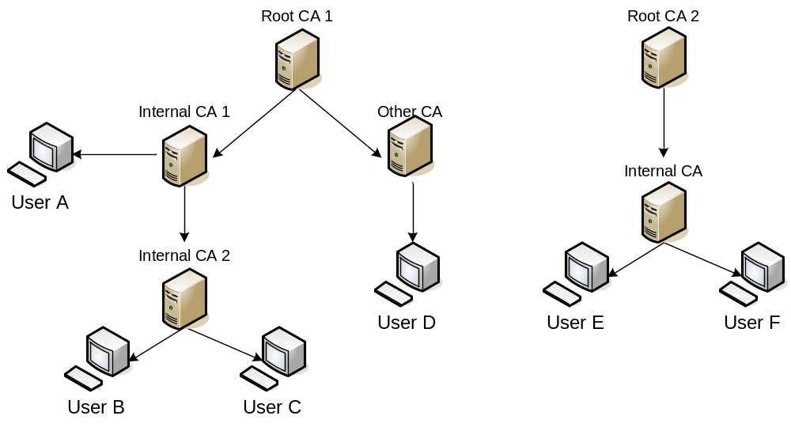

Figure 1 A hypothetical hierarchical trust system [13].

One system that uses a hierarchical trust model is X.509. X.509 assumes that a certificate binds to a person. That person is identified by a globally unique and globally meaningful name that binds them to a trusted root CA [14]. X.509 is the system used by most web browsers today.

Web of Trust
The web-of-trust model differs greatly from the hierarchical model. The hierarchical model is easily represented with computers as a tree, but the web-of-trust more closely relates to how people determine trust in their own lives. As people go through life and meet new people, they look to those they already trust to help make the determination if they should trust these new people. If people they trust already trust this new person, they are more likely to do the same [12].

PGP implements this model by allowing people to sign each other’s keys assigning to each of the keys a level of trust and validity. PGP assumes that a certificate binds a key to a person. That person chooses a name to identify them self, and also provide an email address as a global identifier. When a user signs another user’s key, the signing user is asserting that they have verified that the key truly belongs to the listed user and that it is valid. This method of signing keys leads to an ad-hoc network of trust. Because of the shape of the resulting graph, Phil Zimmerman called this system the “Web of Trust”. The system allows users to specify how much trust to place in a signature by indicating how many independent signatures must be placed on a certificate for it to be considered valid [14].

Figure 2 shows what a Web of Trust for a small group of users might look like.

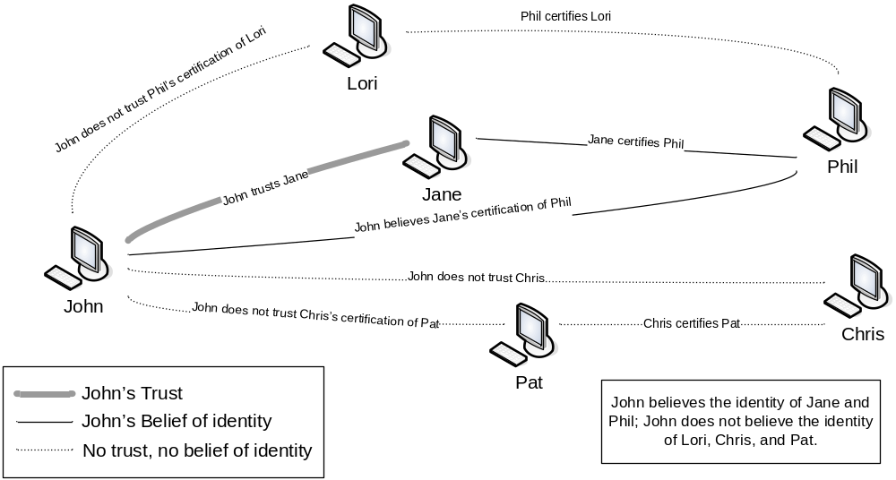

Figure 2 A hypothetical PGP Web of Trust [12].

PGP Key Servers
PGP keys exist for individuals, groups, organizations, network services, and even pseudonyms and anonymous addresses. Unfortunately, it is not always possible to verify a signature made by an arbitrary key, or even to find the key. Although it is possible to advertise a key via traditional Internet mechanisms, this is not always practical, since the key space does not map cleanly onto traditional Internet naming.
To solve this problem, repositories of PGP public keys have been established. These PGP public key servers allow anyone to submit any public keys and signatures, and to query this database. The first public key server was a simple email server which used the PGP program to provide basic PGP functionality on a centrally stored key ring. This server evolved and added features, including more advanced searching and incremental updates between servers. Interactive World Wide Web interfaces followed. Today’s key servers manage thousands of public keys [14]. Generally, servers do not allow users to delete keys [15].
These key servers interact using the protocols described in the IETF RFC 2440 [4]. This protocol describes the methods for storing and retrieving keys formatted with the OpenPGP standard. Some popular protocols for interacting with key servers include LDAP, SMTP and HTTP using the Horowitz Key Protocol (HKP) [16].

Visual Web of Trust
For this project, we chose to utilize the Java J2SE application environment. Java provides a rich environment of excellent existing open source projects that we leveraged to allow us to focus on problem areas of interest and not reinvent the wheel. The project uses the open source Cryptix OpenPGP libraries (http://www.cryptix.org) for interacting with PGP Key Servers and the Java Universal Network/Graph Framework (JUNG: http://jung.sourceforge.net) for displaying the resulting web-of-trust graph [17,18].
The program allows users to enter a search pattern. This pattern can be free-form (such as harvard.edu) or can be for a specific key (such as 0xE3EFE1A7). For free-form searches, all results are displayed as children of the “Search Results” node.
The user can also specify what key server to use as well as the depth of the search to perform. The depth controls how many levels from the root the application should search. If, for example, the user requested a search of depth 3, the program would only recursively search for keys that are less than 3 levels from the root.
The Cryptix libraries interact with key servers that support HKP. HKP uses HTTP GET to retrieve definitions from PGP key servers. A sample session is shown in Table 1.
From this exchange, the Cryptix libraries parse the returned PGP keys. The program then recurses on any new keys, building the graph representation on the fly. Any queries after the initial search use the key ID and not the user ID. Keys are cached during program execution to minimize the load on the key server. The HKP session would look identical with the search field replaced with the hexadecimal key ID.
As the search is being performed, the graph is being built. The graph is a directed, cyclic graph. In the graph, PGP keys are the vertices and trusts are the edges. Once the graph is built, it passed to the JUNG libraries that render the graph.

Table 1 A typical session using HKP to retrieve PGP keys.
Request
GET /pks/lookup?op=get&search=simsong%40acm.org
Response
HTTP/1.0 200 OK
Server: pks_www/0.9.6
Content-type: text/html
<title>Public Key Server—Get “simsong@acm.org”</title>
<p>
<h1>Public Key Server—Get “simsong@acm.org”</h1><p>
<pre>
-----BEGIN PGP PUBLIC KEY BLOCK-----
Version: PGP Key Server 0.9.6
mQGiBD5KqkYRBAC2IJmp9UuAppCWHWtMkcHUS86fThj7f4RuJdKub4IGLmCbNCXi
<...KEY TRUNCATED...>
-----END PGP PUBLIC KEY BLOCK-----
</pre>

People in the web-of-trust can sign each other’s keys. If two people were each to sign each other’s keys, a cyclic graph would occur. In order to prevent the program from constantly searching for the same e-mail addresses, we maintain a global list of all e-mails that were found. If the e-mail address was previously seen no further search is performed on it.
Once the graph has been drawn the user is free to perform a new search or interact with the currently drawn graph. Vertices can be moved to help the user understand who is present in the displayed web-of-trust. Graphs that resulted from some searches are shown in Figures 3, 4 and 5.
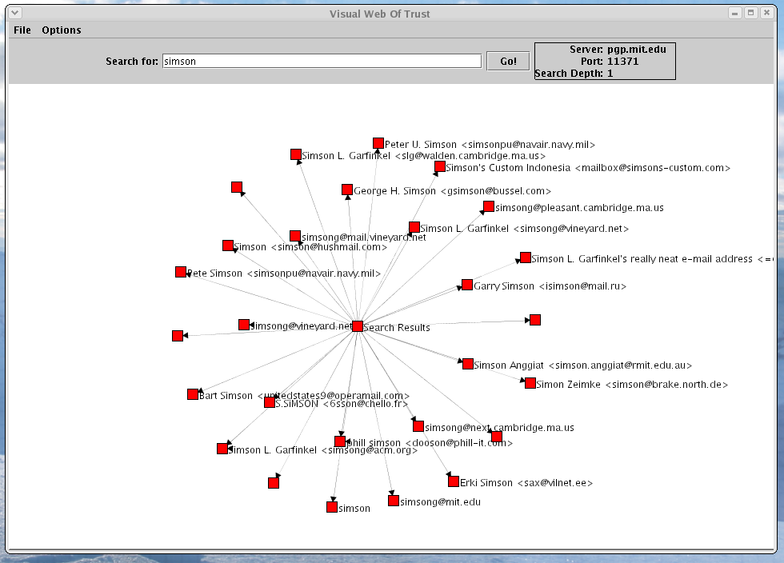
Figure 3 Results of a simple text search displayed as a radial graph.

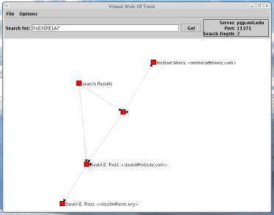
Figure 4 Results of searching for a specific key ID.

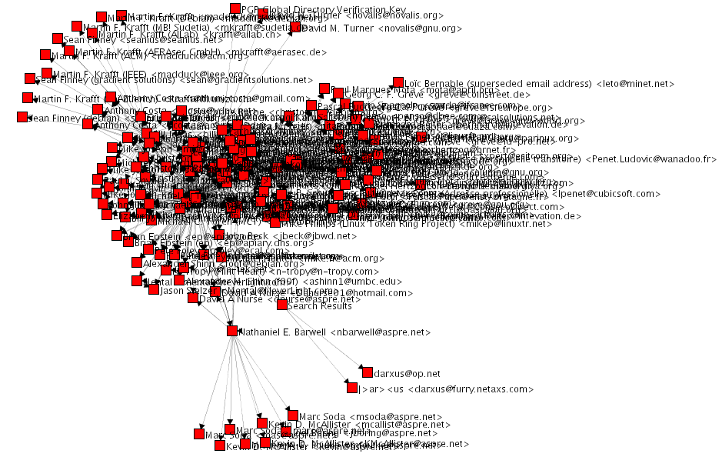
Conclusions and Future Work
Figure 5 Results of searching for a user in a large user group.
The tool that we developed is the first of its kind that allows users to dynamically browse and explore the PGP Web of Trust. By giving the users the ability to view this Web, users will be able to better understand the Web of Trust and make trust decisions more effectively. The tool was written using freely available software and was written in Java. These combine to make the tool highly portable and available to a large number of users.
We see much opportunity for further work on this tool. Some ideas could include:
- Listing all users that appear in a graph in a separate, linked table.
- Allowing users to dynamically filter the graph by level.
- Allowing users to specify a graph layout algorithm.
- Giving the user some basic statistics about the graph.
- Allowing the user to export a report about their findings.

These improvements, when coupled with the current tool, would create an extremely powerful tool that could be used by users, educators and researchers for exploring and understanding PGP space.

References
[1] PGP Corporation – PGP History.
http://www.pgp.com/company/history.html
[2] Origins and Ideas of PGP.
http://www.lugod.org/presentations/pgp/history.html
[3] C. Adams, M. Burmester, Y. Desmedt, M. Reiter, P. Zimmermann. Which PKI (public key infrastructure) is the right one? Proceedings of the 7th ACM conference on Computer and communications security, pages 98 – 101, 2000, New York.
[4] OpenPGP Message Format.
http://www.ietf.org/rfc/rfc2440.txt
[5] GPG Keysigning Party HOWTO.
http://www.rubin.ch/pgp/kspa/gpg-party.en.html
[6] PGP Keys.
http://www.bohn-stralsund.de/t_frame.htm
[7] sig2dot GPG/PGP Keyring Graph Generator.
http://www.chaosreigns.com/code/sig2dot/
[8] PathServer.
http://www.stubblebine.com/researchlabs/keymanagementauthentication.html
[9] Pathfinder.
http://the.earth.li/~noodles/pathfind.html
[10] Sigtrace.
http://www.chaosreigns.com/code/sigtrace/
[11] M. Burmester, Y. Desmedt. Is hierarchical public-key certification the next target for hackers? Communications of the ACM, pages 69-74, August 2004, New York.
[12] S. Garfinkel, G. Spafford. Web Security, Privacy & Commerce. O’Reilly, Cambridge, 2002.

[13] PKI: Build, buy or bust?
http://www.nwfusion.com/research/2001/1210feat.html
[14] SPKI/SDSI and the Web of Trust.
http://theworld.com/~cme/html/web.html

[15] PGP Public Key Servers.
http://www.rossde.com/PGP/pgp_keyserv.html#noremove

[16] M. Horowitz. A PGP Public Key Server.
http://www.mit.edu/afs/net.mit.edu/project/pks/thesis/paper/thesis.html
[17] Cryptix.
http://www.cryptix.org
[18] JUNG – Java Universal Network/Graph Framework.
http://jung.sourceforge.net

